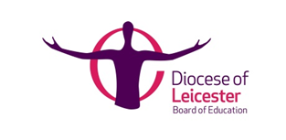
Schools Partnership Agreement

2021 – 2022 Subscription Agreement Form

Name of School / Academy
Address
Email (for invoicing purposes)
Number on Roll

Number of pupils | Cost
105 or fewer | £449
106 - 210 | £549
211 - 315 | £599
316 - 630 | £649
631 or more | £749

We ask all schools to indicate below whether they wish to join the Partnership Agreement and return this form to us
Please put a ‘x’ in the appropriate left -hand box
 | We DO wish to SUBSCRIBE to the Diocesan Board of Education Partnership Agreement for academic year 2021-2022
 | We DO NOT wish to subscribe to the Partnership Agreement for academic year 2021-2022
Please indicate (x) if you intend to access the DBE’s Admission Appeal’s Service if required |  | Yes | No
Signed by Chair of Governors / Headteacher*
Date

*An electronic signtaure is acceptable when sent from a known school email address
Please return a scanned copy of this form to:
OfficeDBE@LeicesterDBE.org
by 27th August 2021

